ACSL
American Computer Science League
2013 - 2014

Contest #3

Senior Division

- Boolean Algebra
Which ordered triple(s) make the following Boolean expression TRUE?

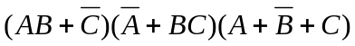

1.

2.
- Boolean Algebra

Simplify the following Boolean expression:

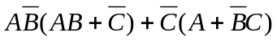

3.
- Graph Theory
How many paths of length 3 are there in the directed graph?

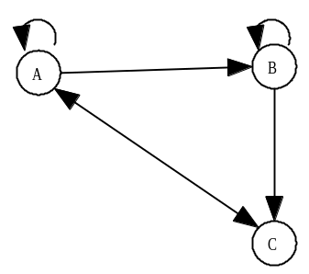

4.
- Graph Theory
How many different cycles are there from A in the directed graph at the right?

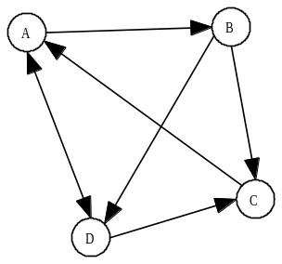

- Bit-String Flicking
Solve the following for X (5-bit string) that satisfies the equation:

(LSHIFT-2 (RCIRC-1 01110)) OR (LCIRC-2 (RSHIFT-1 X)) AND (NOT(RCIRC-1 (LSHIFT-2 01010))) = (LCIRC-2 (NOT 10000))

5.

